**How Java Code Compile And Run ?**

# What Is JDK?

JDK, or **Java Development Kit**, consist of tools that we use them to develop and run Java code. Before develop and run Java code, you should install it in your computer or system. The below picture, represent structure of JDK:

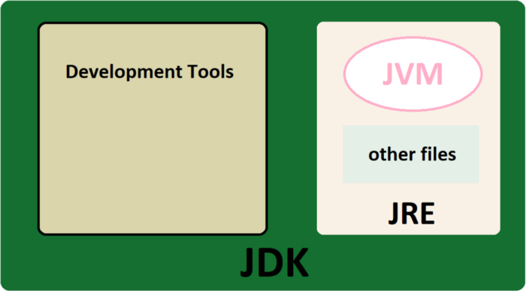

As you see, **JDK**has consists of **JRE** and **Java development tools.**

**JRE** or **Java Runtime Environment is**a packagethat provides an environment to **only run (**not develop) the Java program(or application)on your machine. It is only used to run Java programs.

**JDT**or**Java Development tools** consist of many tools like compiler, debugger, and other development tools.

The most important part of JDK and JRE is **JVM**or**Java Virtual Machine**and its responsibility is execution code line-by-line. It's also knowing as Interpreter. In the following, we will get more acquainted with it.

# How JDK Compile and Run Java code?

At first, Java compiler (Javac, that is in Development tools), convert Java classes (with .java extension) to Bytecode. Bytecode is a file that its extension is .class.

To run code, we need JVM. JVM in each OS is different and to running Java, We require an JVM compatible with the operating system.

Javac (Java Compiler)pass .class file to JVM. Then, In JVM, three stage performed:

◼ Class Loader  
◼ Bytecode Verified  
◼ Java-In-Time Compiler

**Class Loader**, is an object that accept Bytecode (files with .class extensions) and uploads java classes (don't confuse!! Here, classes means object-oriented classes) in Heap Memory.

Then, class loader is checked by **Bytecode Verified.**In this process, problem and dangers of class loader is checked**.**For example, if in the program, we use a variable that has not been declared, or ifthe run time stack overflows, it will throw an Exception and the compiling process will stop.

If our Code doesn't have any issue, the **Just-In-Time (JIT)**compiler converts it to **Native Machine code**. The compile process is done!!